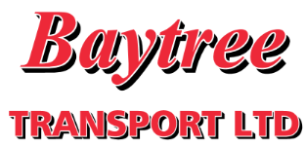
Job Application Form:
- Personal Details
First Name:

Last Name:

Address:

PTO
Postcode:

Home Telephone No:

Daytime Contact No:

National Insurance No:
Email Address:

No
Yes
Are you free to remain and take up employment in the UK?
No
Yes
Do you hold a full driving licence valid in the UK?
Category held:

No
Yes
Do you have any driving convictions?
Please give details if yes e.g. points, date and conviction code below:

Expiry Date:

No
Do you have a valid driver’s CPC?
Yes
No
Yes
Do you hold any other driving related qualifications e.g. ADR, HIAB etc?
Please give details if yes below:

- Education/Qualifications
School/College/University: | Study Dates: | Qualification and Grade: | Date Obtained:

- Employment History
Previous employment: Please include any previous experience (paid or unpaid), starting with the most recent first.

Name of employer: | Address: | Position held and description of duties: | Start and finish date:
Current or most recent employer:
Brief description of duties:

- Declaration

Date:
Signed:

Statement to be signed by the applicant
I agree that Baytree Transport Ltd can create and maintain computer and paper records of my personal data and that this will be processed and stored in accordance with the Data Protection Act 1998.
I confirm that all the information given by me on this form is correct and accurate and I understand that is any of the information I have provided is later found to be false or misleading, any offer of employment may be withdrawn or employment terminated.

